|  |  |
| --- | --- |
|  | FPT ACADEMY INTERNATIONAL  FPT – APTECH COMPUTER EDUCATION |

Centre Name: ACE-HCMC-2-FPT.

Address: 590 Cach Mang Thang 8, District 3, Ho Chi Minh City, Viet Nam.

**[Festivals.cf]**

|  |  |  |
| --- | --- | --- |
| Supervisor: | Phạm Thị Lánh | |
| Term: | T1.2202.M0 | |
| Batch No: | 1 | |
| Group No: | 1 | |
| Order: | Full name | Roll No. |
| 1. | Vũ Duy Hiển | Student1368166 |
| 2. | Nguyễn Huỳnh Anh Tuấn | Student1359475 |
| 3. |  |  |

Month 05 Year 2022

This is to certify that

**Mr. VŨ DUY HIỂN**

**Mr. NGUYỄN HUỲNH ANH TUẤN**

Have successfully Designed & Developed

**Festivals.cf**

Submitted by: **Ms. PHAM THI LANH**

Date Of Issue: May, 2022

Authorized Signature:

# *Content*

Content 3

Acknowledge 4

Synopsis 5

Problem Definition 7

Customer Requirements Specifications 8

Architecture and Design of the project 9

Site map 10

Website Content 11

I. Home Page 11

[II. Event By Region 12](#_Event" \t "II.Event)

III. Event By Seasion 14

IV. About Page 18

V. Contact Page 19

Task Sheet 20

# *Acknowledge*

As we understand that the eProject is a step-by-step learning environment that closely simulates the classroom and Lab based learning environment into actual implementation. It is a project implementation at your fingertips!! An electronic, live juncture on the machine that allows you to.

✓ Practice step by step i.e., laddered approach.

✓ Build a larger, more robust application.

✓ Usage of certain utilities in applications designed by the user.

✓ Single program to unified code leading to a complete application.

✓ Learn implementation of concepts in a phased manner.

✓ Enhance skills and add value.

✓ Work on real life projects.

✓ Give a real-life scenario and help to create applications more complicated and useful.

✓ Mentoring through email support.

We would like to send a great thank to our professor and others student for the adorable support during the time in the project.

Beside several mistakes we had made in the project, we hope to have more opportunities to widen our knowledge in the web developing world.

We also thank you so much for your information and the “demo” project from India APTECH to help us get more reality experience in this project. Since we have gained more experience from this project, we will not stop learning anything as much as we can to be more successful in the future.

Your Sincerely,

Team Group 01.

# *Synopsis*

-The Objective of this program we aim is to give a sample project to work on real life projects. These applications help us build a larger, more robust application.

-The objective is not to teach us HTML/JavaScript but to provide us with a real life scenario and help us create basic applications using the tools.

-Hence, we can revise the chapters before we start with the project.

-This project The Objective of this program is to give a sample project to work on real life projects. These applications help you build a larger, more robust application.

-The objective is not to teach you the software but to provide you with a real-life scenario and help you create basic applications using the tools.

-You can revise the topics before you start with the project.

-This project is meant for students who have completed the module of HTML5.

-These programs should be done in the Lab sessions with assistance of the faculty if required.

-The website (in this project) is a tool that help the company to access the

international market and gain more and more new customers.

-It is very essential that a student has a clear understanding of the subject.

# 

# *eProject Report Details*

## Problem Definition

Festivals.cf is an website which provides information about various festivals which are celebrated across the world. The site should provide the data in proper categorization like Christians festival link will enlist the festivals celebrated by them. The details of the festivals must include date when it is celebrated, why (historic reason behind it), some images regarding. Apart from the information, a gallery link can be added which will consist of images of the festivals. Uniform theme and proper sequence navigation is expected.

You are supposed to create a website for them with the below mentioned requirement specifications.

The website is to be developed for the Windows Platform using HTML5, JavaScript and Geolocation. The site should work well in all leading browsers including Chrome, IE, Firefox etc.

**Requirement Specification:**

The Web site is to be created based on the following requirements.

1. The Home Page should be created making use of Sections with a suitable logo
2. The site should display a menu which will contain the options for brief introduction about the various categories or link, and about is feedback and so on.
3. Links of the all the religion can be added and each religion link must open the list of the festivals coming under them.
4. The images of each festival must be added.
5. Navigation of the project must be made smooth and uniformity must be expected.
6. Various books based on the festivals must be added in the webpage, which user can see and purchase (for purchasing section the dummy procedure must be used).
7. Site map, Gallery, About us, Queries link, Contact us link must be added. Address of the Company should be displayed using GeoLocation API (eg. GoogleMaps).
8. The complete historic reason and its description must be allowed to get download as pdf or doc file.

## Customer Requirements Specifications

|  |
| --- |
| USER: |
| Input:  ● Input Country User Want To Go (Event Page)  ● Input Filter of Season (Event Page)  ● Input User Information To Send Message Feedback (Contact Page) |
| Process:  ● Using Java Script To Make Input Function (Event Page)  ● Using Jave Script To Collect Information & Message (Contact Page) |
| Output:  ● Show Festival by Information User Input (Event Page)  ● Alert On Website Information & Message Of User Feedback (Contact Page) |

|  |
| --- |
| HARDWARE / SOFTWARE REQUIREMENT: |
| Software:  ● Notepad/HTML editor  ● Dreamweaver/Javascript |
| Hardware:  ● A minimum computer system that will help you access all the tools in the courses is a Pentium 166 or better  ● 64 Megabytes of RAM or better |

## Architecture and Design of the project

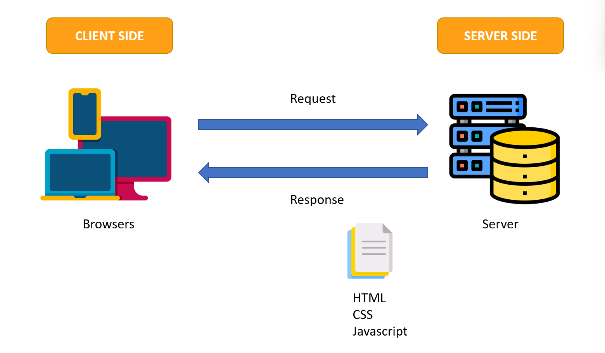

## Site map

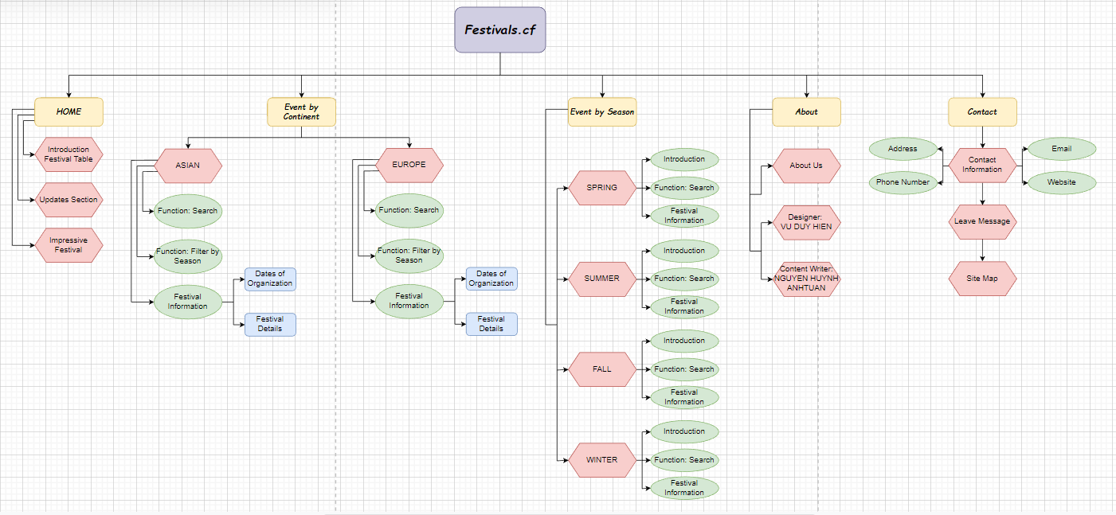

## Website Content

### Homepage:

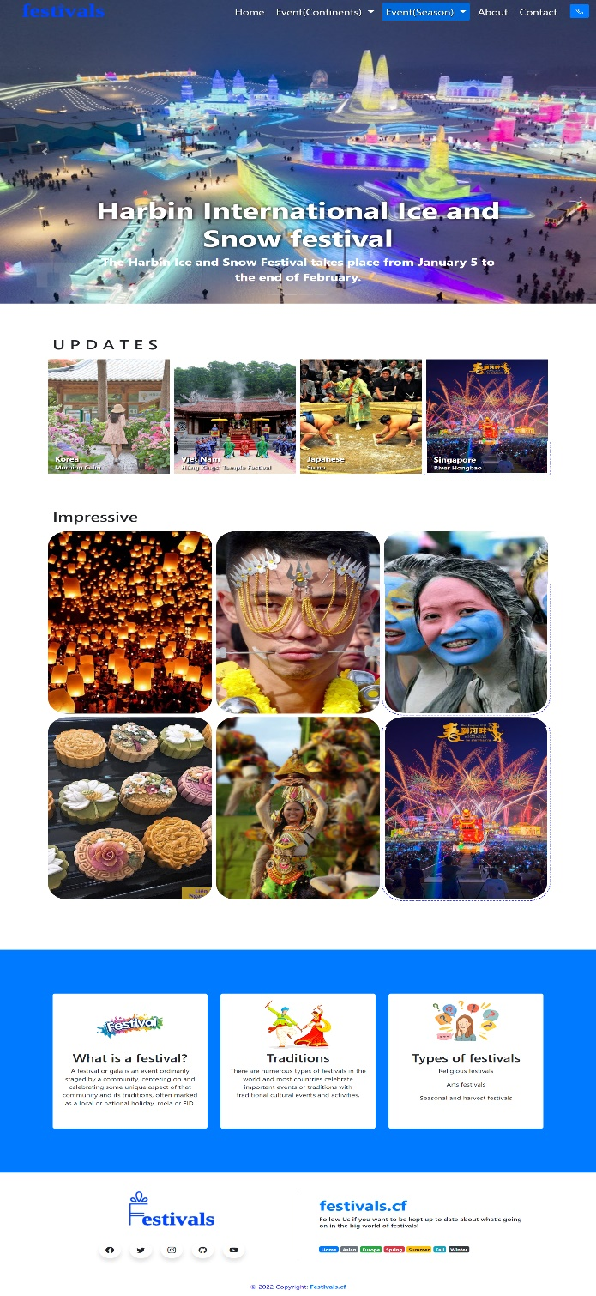

**Description:** This is the festival's homepage, at the top of which is the logo and navigation bar, followed by the slideshow. The main part of the homepage consists of new articles, followed by featured images, and then a brief history of festivals. And finally, the bottom of the page includes featured images and social media links

### 

### Event by Asia Region:

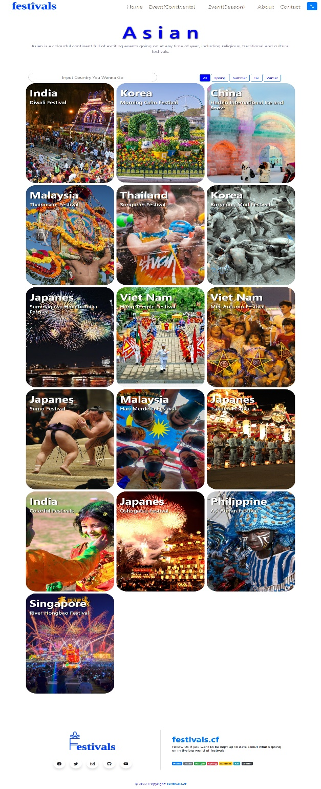

**Description:** When user choose Asia Region, we will introduce Asia Festival and Information for you to choose.

### Event by Europe Region:

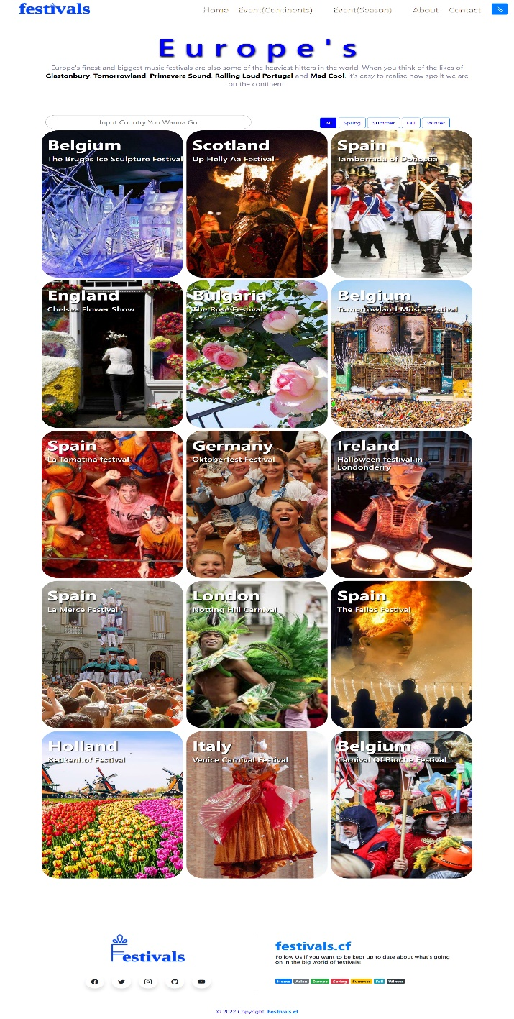

**Description:** The same as Asia, when user want to learn about Europe, let us do it, all you need to do is click and choose where you want to go.

### Event by Season:

* *Festival of Spring:*

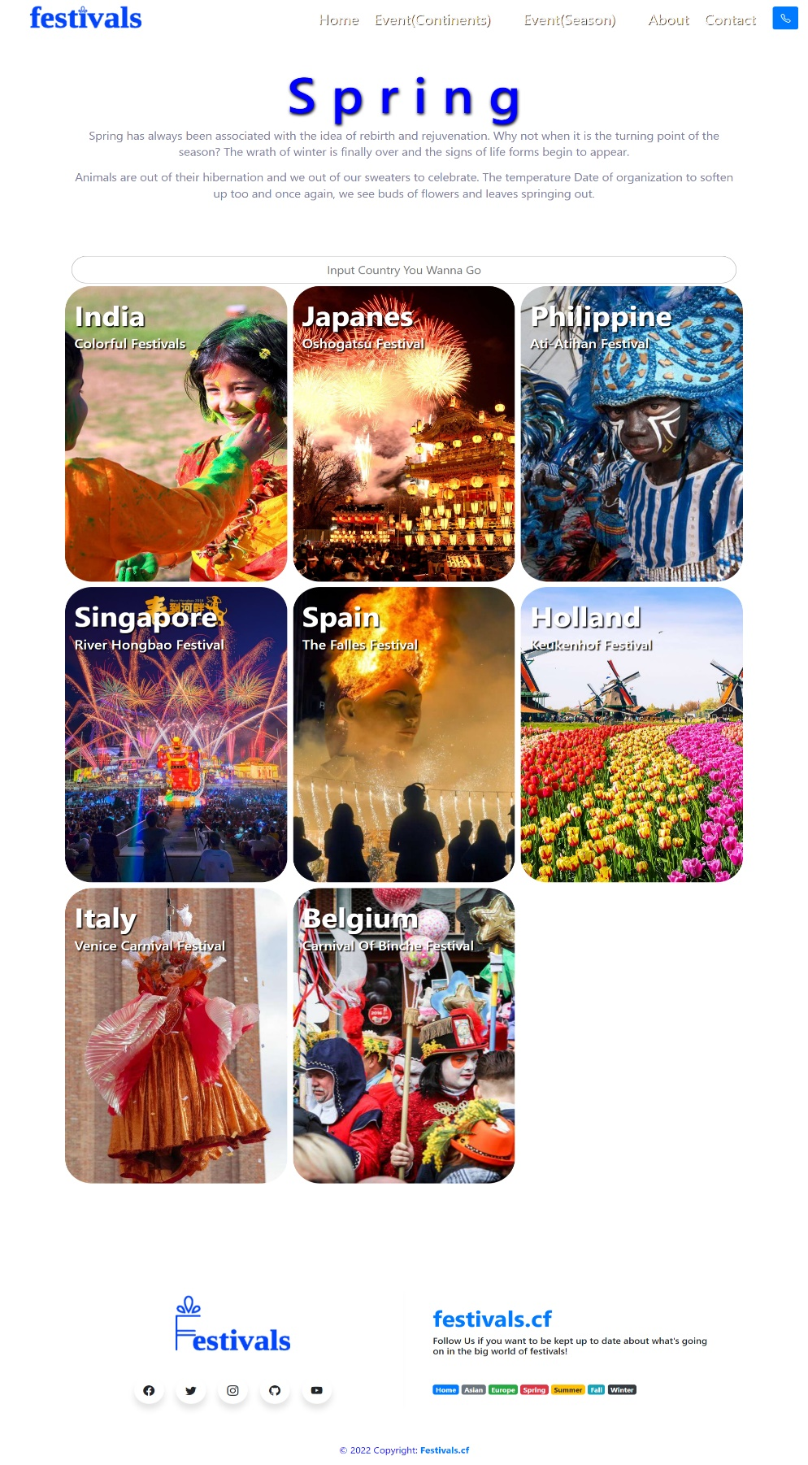

* *Festival of Summer:*

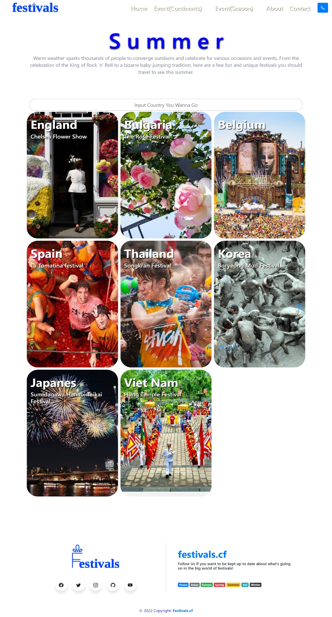

* *Festival of Fall:*

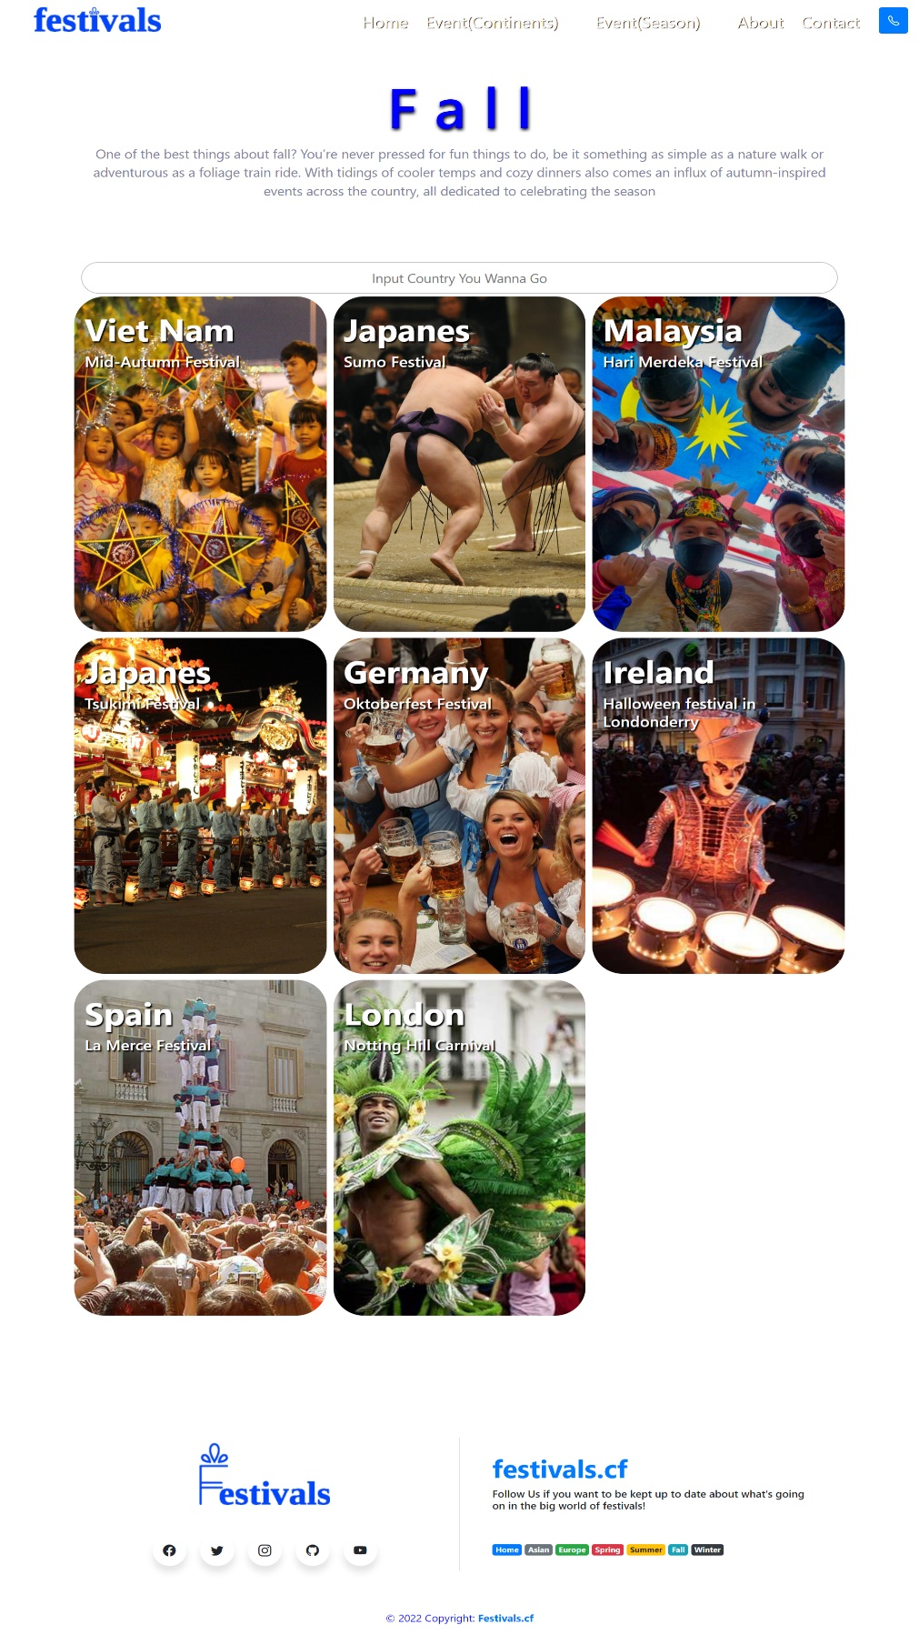

* *Festival of Winter:*

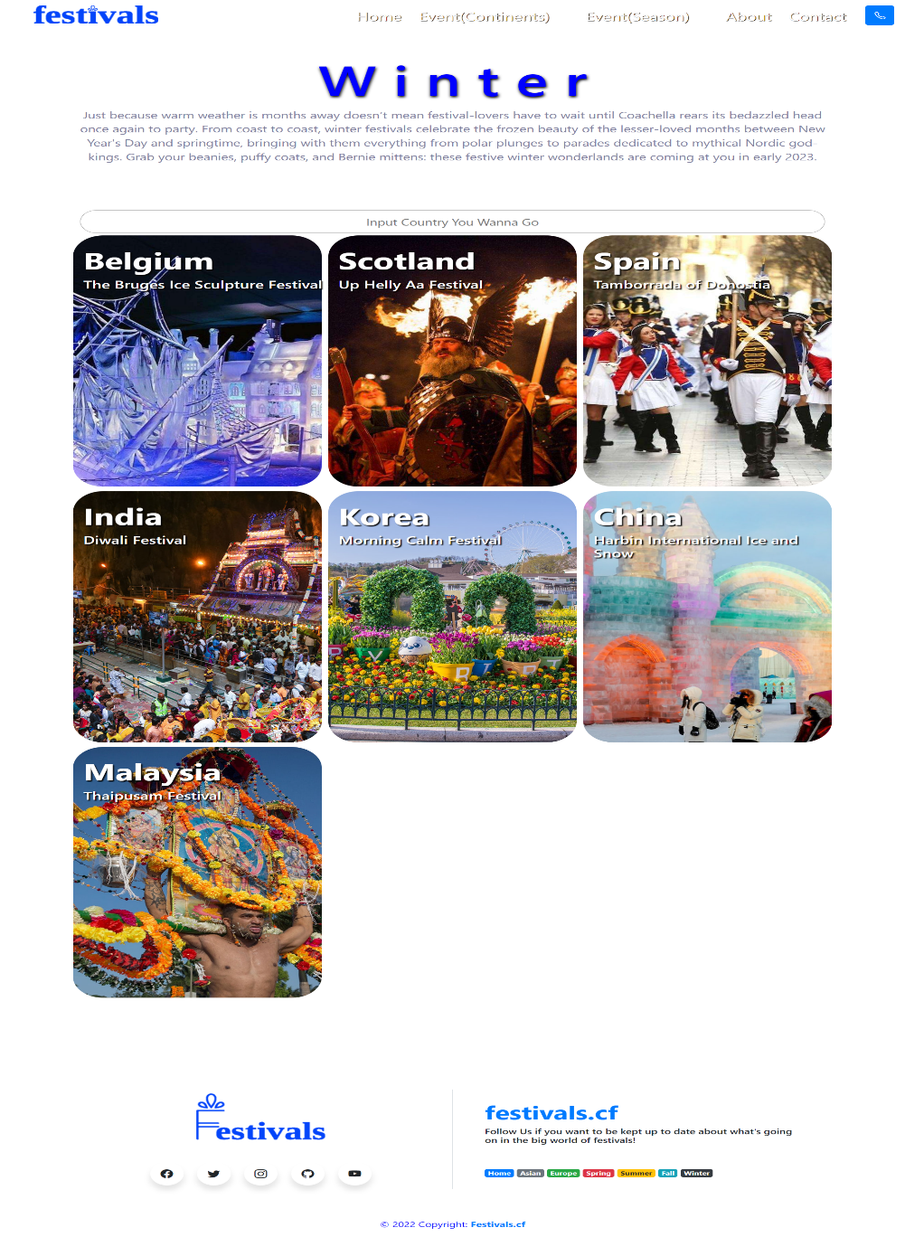

**Description**: More detail about where user want to spent their vacation, we also make a filter for user to choose Festival by Season. Make your choice more easily and a better experience

### About:

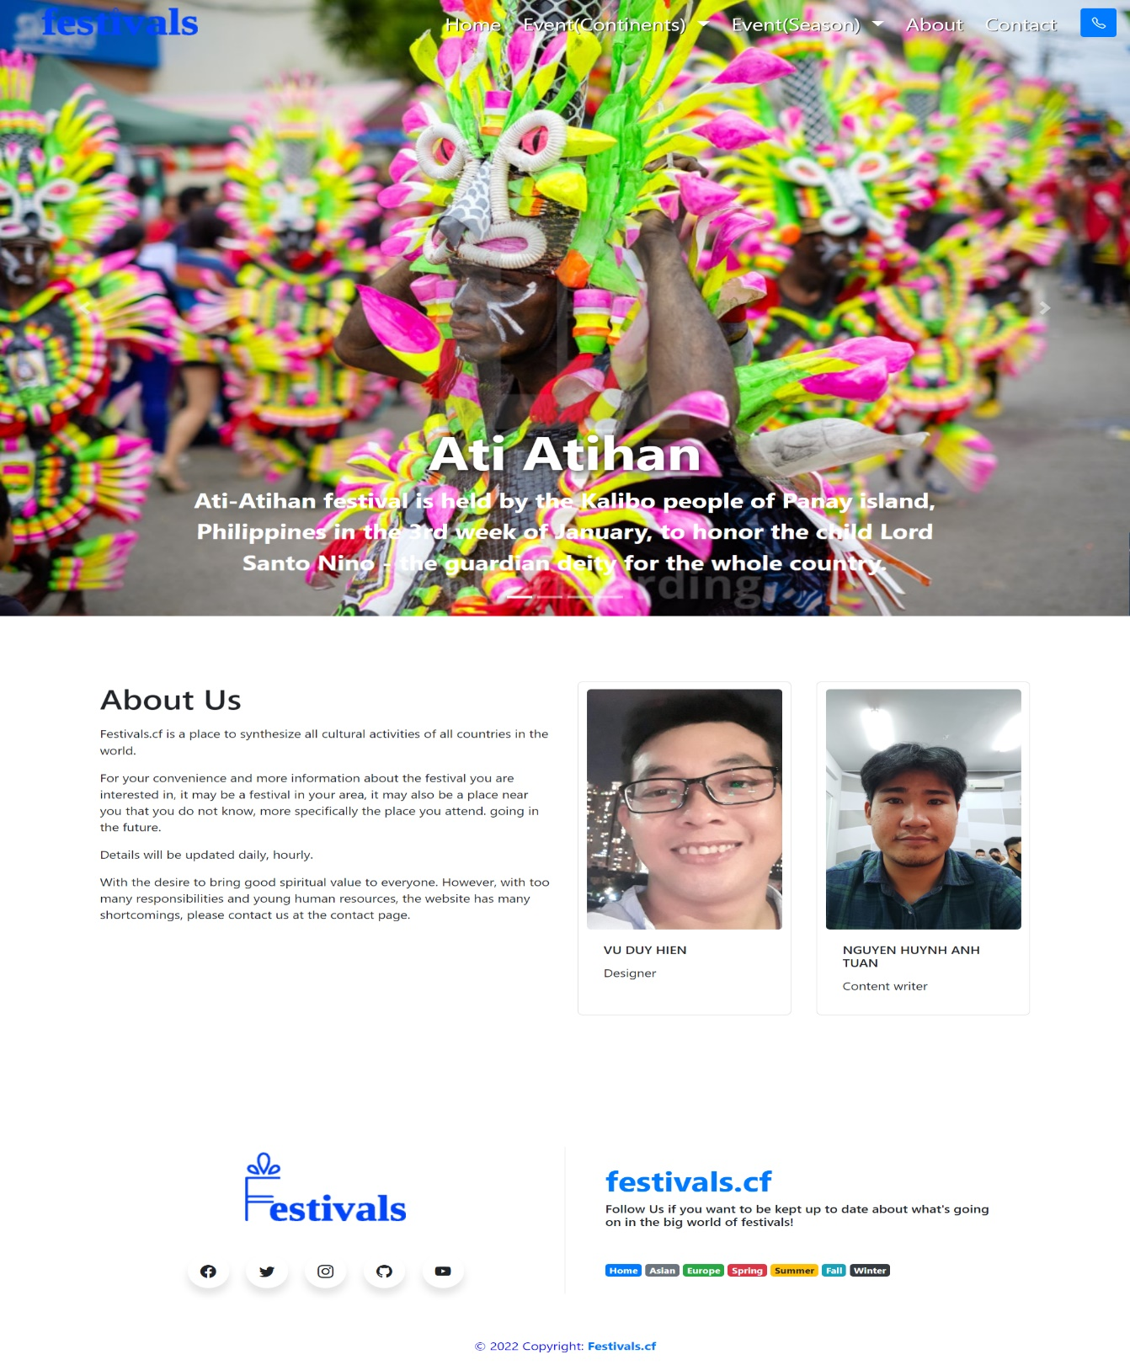

**Description:** With all our efforts and efforts, our team has been creating a website that brings a great experience to users during their holidays. With just a few clicks, users can filter festivals according to their needs without having to think too much.

### Contact:

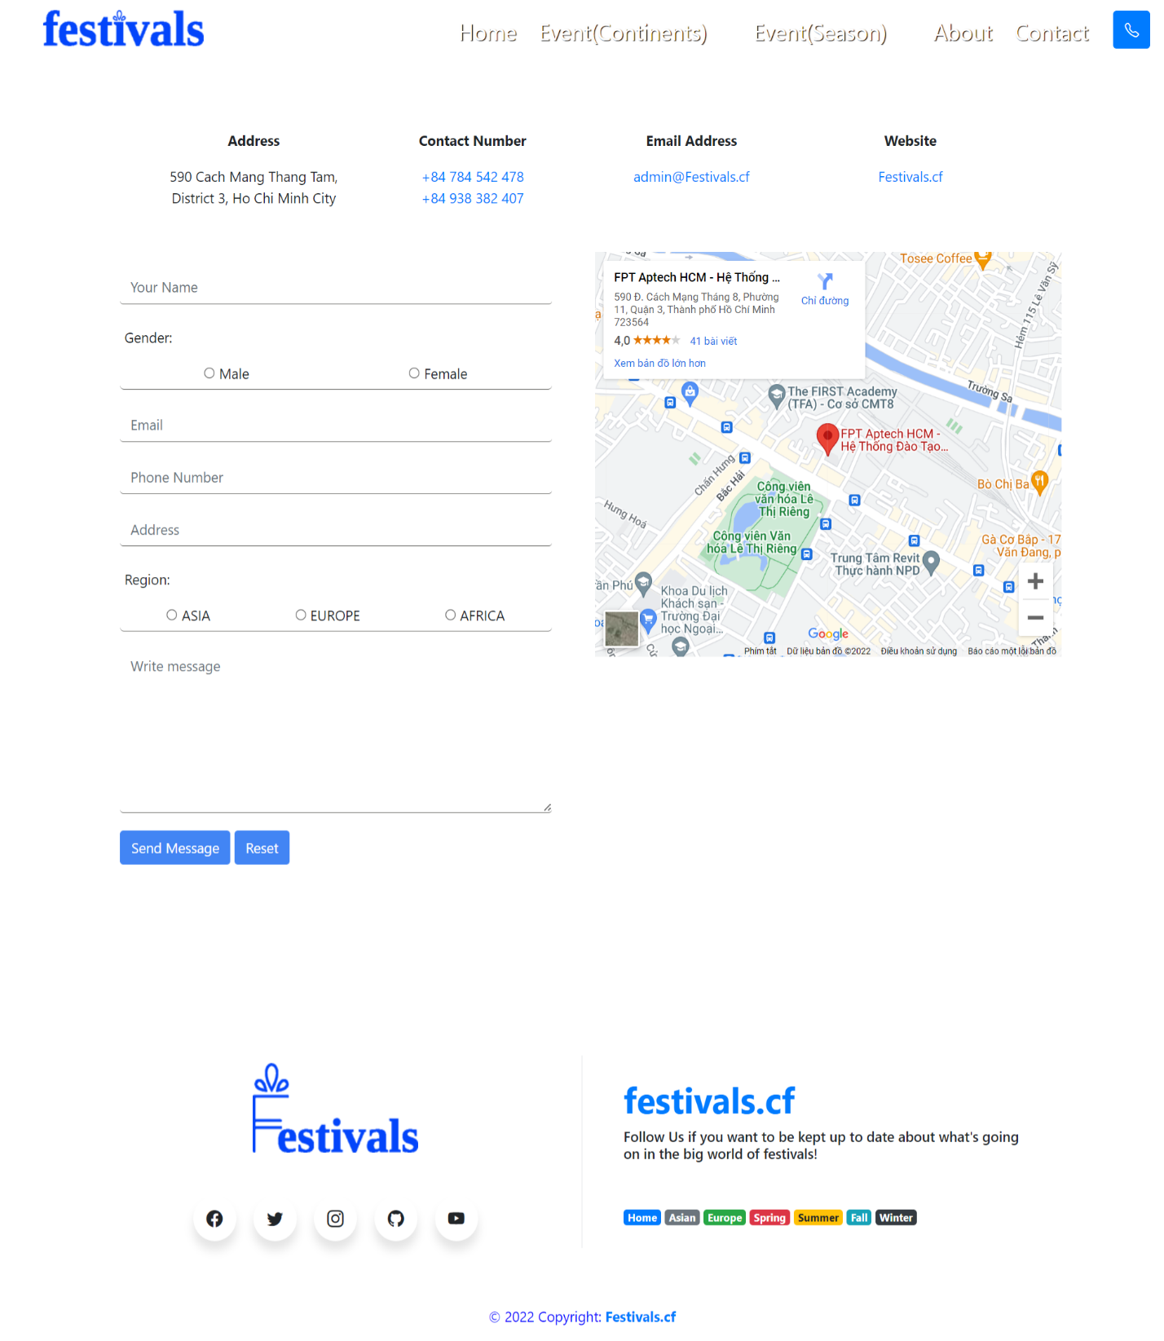

**Description:** Finally, in addition to providing users with a festival search service, we always aim to listen and receive users' suggestions to improve and provide more user-friendly updates. . So speak up, we're always here to listen. We always want to give you the best experienc

## Task Sheet

|  |  |  |  |
| --- | --- | --- | --- |
| **e P r o j e c t s S t a t u s R e p o r t** | | | |
| Student Details | ***No*** | 1 | 2 |
| ***Full name*** | Vu Duy Hien | Nguyen Huynh Anh Tuan |
| ***Student Id*** | Student1368166 | Student1359475 |
|  |  |  |  |
| eProject Details | ***eProject Title*** | Festival Website | |
| ***Duration*** | 4 weeks | |
| ***Start Date*** | 18/5/2022 | |
| ***End Date*** | 18/6/2022 | |
|  |  |  |  |
| eProject Task | ***Task*** | ***Done By*** | ***Status*** |
| 1-Completing the code | Vu Duy Hien | Completed |
| 2-Edit content accordingly | Nguyen Huynh Anh Tuan | Completed |
| 3-Add Search function | Nguyen Huynh Anh Tuan | Completed |
| 4-Add Filter function | Vu Duy Hien | Completed |
| 5-Completing the About page | Vu Duy Hien | Completed |
| 6-Completing the Contact page | Nguyen Huynh Anh Tuan | Completed |
| 7-Overall inspection of the entire project | Vu Duy Hien &  Nguyen Huynh Anh Tuan | Completed |